Rogelio Murillo
CS-250: Object Oriented Programming
Professor Rosasco
11/29/23
Working Paint UMLs

CLASS DIAGRAM:
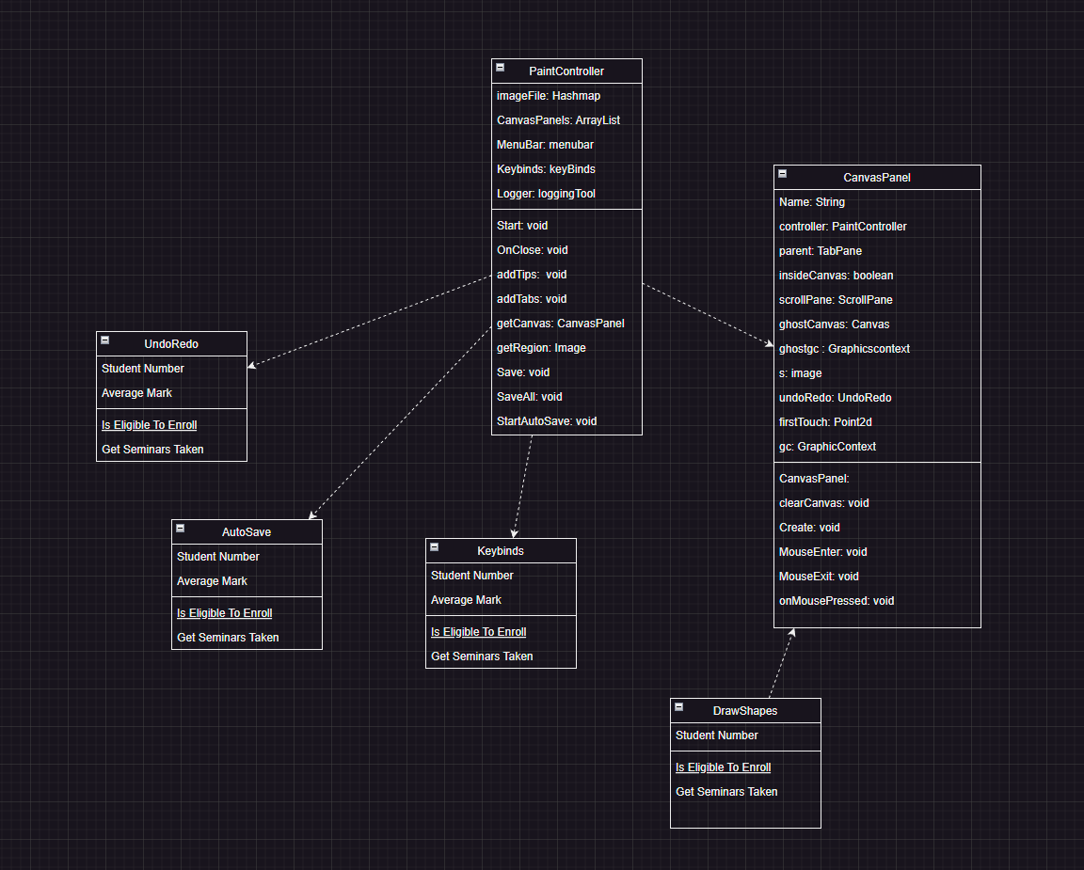
CASE DIAGRAM

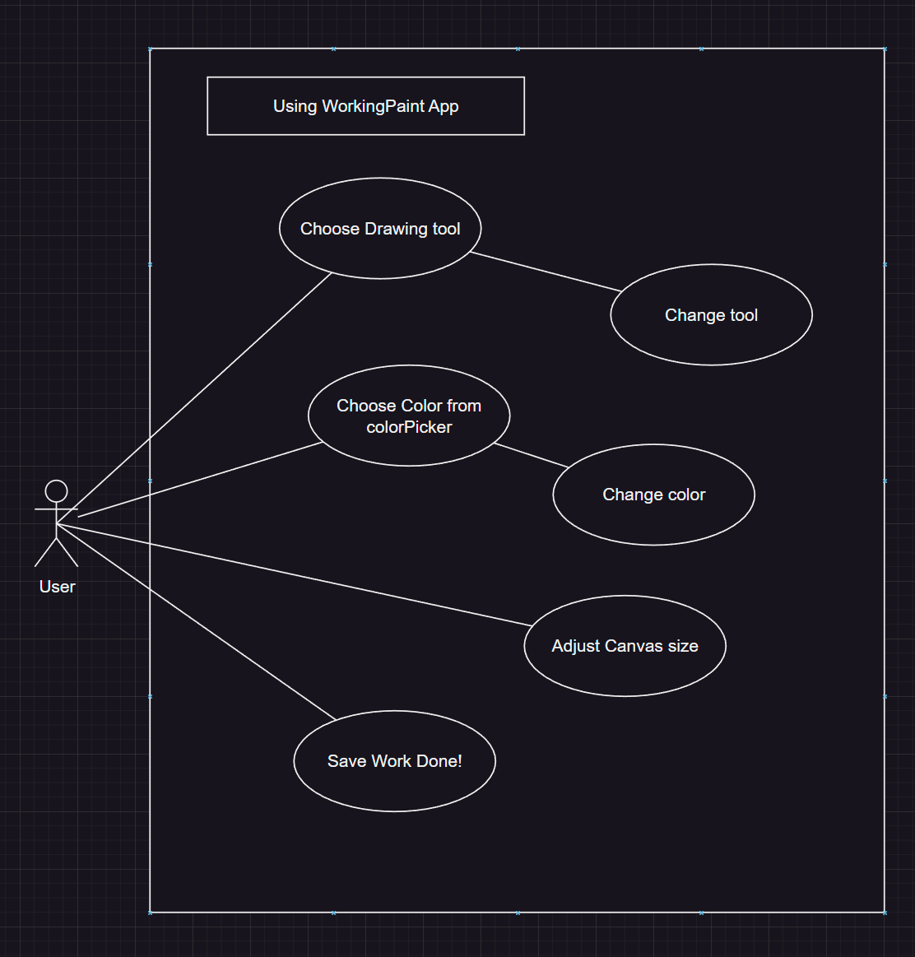
ACTIVITY DIAGRAM

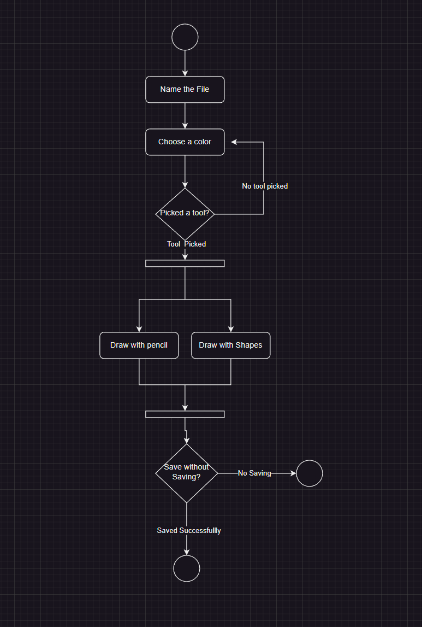
Case Diagram 2:

